

**Name: Paradise Luxury**

**Price: 1300$/hour**

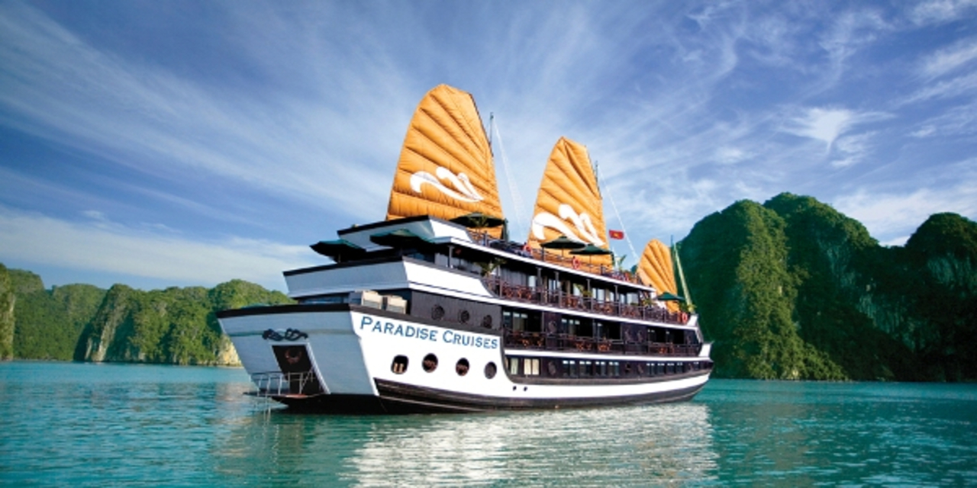

Paradise Luxury is a traditional wooden yacht that harmoniously blends modernity, luxury and national identity. The interior of the ship is entirely made of wood, bringing a warm, classic feeling that is extremely charming but still ensures maximum comfort for guests.

Paradise Cruises owns the largest cabins with private balconies, separate spa and massage areas, large and light-filled restaurants, perfect bar and sundeck. We have selected unique designs and the finest natural materials - precious wood, Khai Silk, linen, taffeta, marble, porcelain, crystal and delicate silver are just a few examples. Combining classy luxury with Vietnamese hospitality, we want guests to feel absolute relaxation and true luxury aboard a high-class yacht.

|  |  |
| --- | --- |
|  |  |
|  |  |
|  |  |
|  |  |

|  |
| --- |
| ***​*** |
|  |
|  |

***​DESCRIPTION***

|  |  |  |  |
| --- | --- | --- | --- |
|  | **Long 162.5m** |  | **Wide 22.4m** |
|  | **18 Room** |  | **36 Guests** |
|  | **1 x 300 HP** |  | **21 Knots** |
|  | **Day Charter** |  | **30 L/h** |

ROAD CHARTER

»» Sightseeing on the Saigon River by yacht in 2 hours.  
1. Sunset and city night life.  
2. Enjoy the freedom & fresh air.  
  
»» Saigon – Can Gio Mangrove Forest 4 hours.  
1. Enjoy the mangrove forest and the life of local fisherman.  
2. Buy and cook local seafood from the forest fisherman. The special seafood of brackish water.  
3. Sunset on the river  
4. Night life of the city  
  
»» Saigon – Vung Tau City  
1. The trip will go through Can Gio Mangrove Forest.  
2. Swimming in the open sea (near the coastine)  
3. Sunset on the river  
4. Night life of the city